Sustainability Policy

TRANS-TECH is committed to operating under Sustainable Business Practices that meet today’s needs without compromising the ability of future generations to meet their own. We employ a management system approach to:
- Comply with applicable laws, regulations and requirements
- Prevent pollution, conserve resources, and minimize waste
- Cultivate safe, healthy, and productive work environments
- Operate with integrity, honesty, and accountability
- Foster continuous improvement
- Promote Sustainability throughout our supply chain

Lockout/Tagout

It is important that contractors and company personnel are aware of each other’s respective Lockout/Tagout programs. If there are any differences in the programs, they are to be communicated during the pre-job meeting. It is expected that the contractors programs shall be at least as restrictive as TRANS-TECH program.

Chemical Safety

Contractors shall immediately notify the EH&S Coordinator of any chemical being brought onto TRANS-TECH property and supply the EH&S Coordinator with a current SDS.

Contractors shall not dump any chemicals or oils into the company dumpsters or down any company drains. Contact the EH&S Coordinator for the proper disposal of any waste materials.
Contractors shall IMMEDIATELY notify the EH&S Coordinator or their company contact in the case of a hazardous material spill.

Ladder Safety

Contractors using their own ladders on TRANS-TECH property will inspect them before each use. Any ladder found to be unsafe, damaged or not the proper type shall be removed from the company property immediately. Contractors will not use ladders in an unsafe manner including standing on the upper rungs or the top of the ladder.

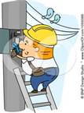

Emergency Contact
Information:

Facilities Manager
Gino Lombardi
(c) 301-748-1406

EH&S Coordinator
David Tolino
(c) 301-401-2706

Dial 911 for Emergencies

NOTE: When using an internal TRANS-TECH phone you must dial 9911.

TT-F0604, Rev. 9

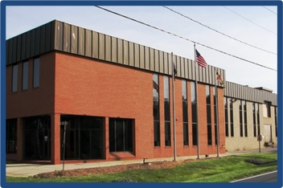
Adamstown, Maryland

Contractor’s Safety Pamphlet
Emergency Preparedness, Environmental and Safety Requirements

Emergency Evacuation Procedures
Quickly and safely exit the building when the Fire Alarm sounds. Proceed to the Evacuation Meeting Area at the far end of the main parking lot. Check in with your TRANS-TECH company contact or the Incident Commander.
NOTICE: All visitors and contractors are required to sign into the visitor’s log book in the main lobby. Additionally, all contractors must review and sign-off annually the Contractors Safety Presentation.

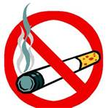

Smoking Policy
No smoking is allowed inside the factory and is only permitted in the front of the building near the Waste Water Treatment Plant or in the rear parking lot at the smoking shelter.

Personal Protective Equipment

Contractors will wear the proper Personal Protective Equipment as indicated by the area they are working in and the type of work they are doing. Contractors will provide their own Personal Protective Equipment.

Permit Required Operations
Contractors will be instructed on what permits are required for the work being performed by their TRANS-TECH contact person. Confined Space, Hot Work and Lockout/Tagout are some of the required permits.

Parking Policy
Contractor should park in the designated Visitors Parking near the Main Entrance. If they need to park elsewhere on the property do not block egress for the forklifts or shipping and receiving trucks.

Eating & Drinking
No food is allowed in any production areas. Drinks must be in an approved spill proof covered container. Vending machines are available in the cafeteria for contractors to use.

